Development and Validation of Stability-indicating method for the determination of Pregabalin by RP-HPLC
Shweta More, Pratima Tatke
Moreshweta821@gmail.com
C.U. Shah College of Pharmacy
ABSTRACT
Pregabalin is an anti-convulsant drug used for neuropathic pain. Pregabalin binds to the alpha-2-delta sub-unit of the voltage-gated calcium channel in the central nervous system. The aim of the present study was to develop the stability indicating, highly accurate precise and linear method for related substance of the Pregabalin through the reverse phase HPLC and to validate as per the current ICH guideline. The optimize method uses a reverse phase column, Inertsil ODS 3V (250 mm × 4.6 mm, 5µ), mobile Phase of Di-ammonium hydrogen phosphate buffer (6.5 ± 0.05) and Acetonitrile through gradient flow rate of 0.8 ml/min. Keeping the column at temperature 25°C and using the sample amount 20 µL and detected all the impurities at 210 nm by the UV detector. In the developed method, elution of Pregabalin was at 11.5 min and all the eluted impurities were well separated and met the system suitability criteria. The precision is exemplified by relative standard deviation of 1.4%. Method percentage mean recoveries of all the impurities are within the range (90.0% to 115.0%) as per the protocol. The method was found to be robust. Linearity coefficient for all Impurities was more than 0.999. The LOD obtained was 0.004% and LOQ is 0.012%. Stability-indicating forced degradation established studies show results that there was no interference of any degraded products or external environment. A new highly accurate, precise and stability indicating method was developed for related substance of Pregabalin with all the impurities well separate from the degradation product of Pregabalin.
Keywords: Pregabalin, RP-HPLC, Stability indicating method.

1. INTRODUCTION
Drug stability is the capacity of a drug substance to remain within established specifications of identity, strength, quality and purity in a specified period of time. The factors that affect drug stability come from the atmosphere such as light, moisture, temperature, acid-base condition and chemical and physical properties of drug which are considered from the quality of raw material such as purity, impurities, crystal or polymorphic form, particle size and residual solvent¹. Therefore, the stability testing was needed to provide evidence how the quality of drug substance or drug product varies with the time under the influence of a variety of environmental factors. (The United State Food and Drug Administration 2003:2)².
According to FDA guideline (Guidance for industry, analytical procedure and methods validation, FDA, 2000), a Stability indicating method is defined as a validated analytical procedure that accurate and precisely measure active ingredients (drug substance or drug product) free from process impurities, excipients and degradation products³. A Stability indicating method is a quantitative test method that can detect possible degradants and impurities of drug substance (API) and drug products, normally using High Performance Liquid Chromatography (HPLC)⁴.
Stability information on both drug substances and drug products is required as part of the registration dossier and serve to assign the shelf-life, determine appropriate storage condition and assure that the quality of the product is unchanged from the time of manufacture to the time of administration to the patient⁵.
Forced degradation studies are used to identify reactions which may occur to degrade a processed product. Usually conducted before final formulation, forced degradation uses external stresses to rapidly screen material stabilities⁶. Forced degradation is a process that involves degradation of drug products and drug substances at conditions more severe than accelerated conditions and thus generates degradation products that can be studied to determine the stability of the molecule. The samples generated from forced degradation can be used to develop the Stability indicating method which can be applied later for the analysis of samples generated from accelerated and long term stability studies. Procedure for the preparation of specific degradation products needed for method validation often emerge from these studies⁷.
Recently, there is an increased tendency towards the development of stability-indicating assay, using the approach of stress testing as described in the International Conference on Harmonization (ICH) guideline Q1AR(2)⁸. Furthermore, the Stability-indicating assay method is used to prepare stability data for the Pharmaceutical registration⁹.
Pregabalin is a gamma-amino butyric acid (GABA) derivative that functions as a calcium channel blocker and is used as an analgesic in the treatment of neuropathic pain and fibromyalgia. Although the exact mechanism of action is unknown Pregabalin selectively binds to α-2-delta (A2D) subunits of presynaptic voltage- dependent Calcium channels (VDCCs) located in the central nervous system (CNS). Binding of Pregabalin to VDCC A2D subunits prevents calcium influx and the subsequent calcium dependent release of various neurotransmitters including glutamate, norepinephrine, serotonin, dopamine and substances from presynaptic nerve terminals of hyper-excited neurons. Synaptic transmission is inhibited and neuronal excitability is diminished¹⁰.
2. AIMS AND OBJECTIVES
The aim of the current research is to develop and validate the stability indicating method by HPLC of Pregabalin API to accurately measure the active ingredients without interferences from the degradation products.
The objective of this work is enlisted below:
- To reveal the degradation mechanisms such as hydrolysis, oxidation, thermolysis, or photolysis of drug substance
- HPLC Method development and optimization of Pregabalin
- To establish stability indicating nature of the developed method
3. PLAN OF WORK:
- The proposed plan was based on literature survey and evaluated facts. The research plan was carried out in the following steps:
- 3.1. Literature survey
- 3.2. Preparation of standard and test solution
- 3.3. Method development and optimization
- 3.4. Method validation.
- 3.5. Consolidation of results and report writing.
4. METHODS
In the present work, an analytical method based on HPLC using UV detector was developed and validated for determination of Pregabalin API. The analytical conditions were selected, keeping in mind the chemical nature of Pregabalin. The column selection was done on the basis of resolution, peak shape and retention time. After evaluating all these factors, Inertsil ODS-3V (4.6250 mm), 5μm was found to be giving satisfactory results. The selection of buffer was done based on the chemical nature of the drug. Considerably good results were obtained with 0.01M ammonium-di-hydrogen phosphate pH 6.5. For the selection of organic constituent of mobile phase, acetonitrile was chosen to reduce the longer retention time and to attain good peak shape. Finally, by fixing 0.01 M ammonium-di-hydrogen phosphate pH 6.5 and mobile phase composition consisting of mixture of 0.01 M ammonium-di-hydrogen phosphate pH 6.5 : acetonitrile (95:5%, v/v). During the development stage it was found that by using isocratic elution, the retention time was 21 minutes. Therefore, the gradient elution mode was selected to shorten the run time. Optimized proportion of mobile phase has shown good resolution for Pregabalin API as well as for its degradation products which was generated during forced degradation studies. Wavelength selection was done on the basis of significant absorbtion of the drug as well as its impurities.
Table 1: Details of mobile phase and specifications of parameters
Sr. no | Parameters | Specification
1. | Column | Inertsil ODS 3V (250*4.6 mm), 5μ.
2. | Mobile phase A and B (for gradient elution) | - Buffer: acetonitrile (95:5 v/v)  - Buffer: acetonitrile (50:50v/v)
3. | Column temperature | 25°C
4. | Flow rate | 0.8 ml/min
5. | Wavelength | 210 nm
6. | Injection volume | 20 μL
7. | Run time | 60 min
8. | Elution mode | Gradient
9. | Retention time | 11.5mins

Table 2: Summary of analytical method validation data- HPLC Related substances method
Test Parameters | Pregabalin
Precision | % RSD 1.4 (system precision)  % RSD 0.6 (system precision)  % RSD 4.4 (system precision)
LOQ | 100.3 % (Pregabalin RS-1)  100.4 % (Pregabalin RS-2)  100.8 % (Pregabalin RS-3)  98.5 % (Pregabalin RS-4)  101.0 % (Pregabalin RS-5)
LOD | 101.2 % (Pregabalin RS-1)  101.5 % (Pregabalin RS-2)  96.8 % (Pregabalin RS-3)  103.2 % (Pregabalin RS-4)  101.4 % (Pregabalin RS-5)
Linearity | Correlation coefficient:  0.9998 (Pregabalin RS-1)  0.9996 (Pregabalin RS-2)  0.9998 (Pregabalin RS-3)  0.9998 (Pregabalin RS-4)  0.9998 (Pregabalin RS-5)
Accuracy | 98-102%
Solution stability | Stable up to 48 hours
Robustness | Resolution between Pregabalin RS-3 and Pregabalin >3.0

Table 3: Summary of degradation results under various stress conditions
 | Stress type | Condition | Normal sample (total impurity) | Degraded sample (total impurity) | Actual degradation
Acid degradation |  | Exposure to 1ml 5 N HCl and heat at 80°c for 3 hrs. | Not detected | 0.31 | 0.31
Alkali degradation |  | Exposure to 1ml 5.0 N NaOH and heat at 80°c for 3 hrs. | Not detected | 2.73 | 2.73
Oxidative degradation |  | Exposure at 60°c for 7 days. | Not detected | 42.75 | 42.75
Thermal degradation |  | Exposure to 1.2 million Lux hrs and near UV energy of NLT 200 watt hrs/sq.mt. | Not detected | Not detected | Not detected
Photolytic degradation |  | Exposure to 1.2 million Lux hours at 200 watt hours/square meter ultraviolet energy. | Not detected | Not detected | Not detected
Humidity |  | Exposure at 40°c and 75% RH for 7 days | Not detected | Not detected | Not detected

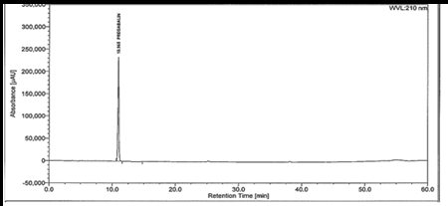
Fig 1: Representative Chromatogram with optimized conditions
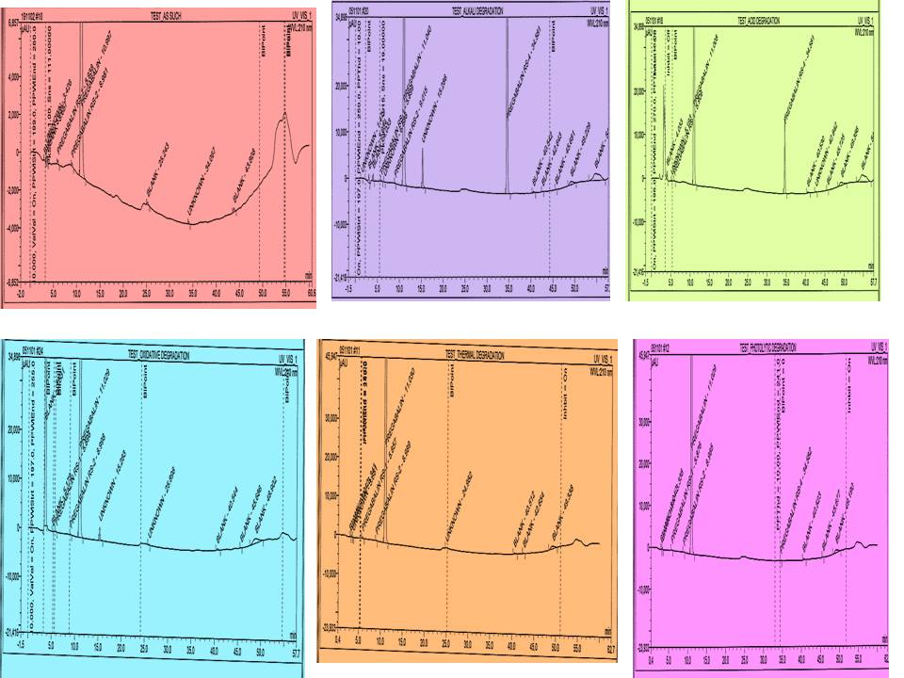
Fig 2: Representative Chromatogram of forced degradation studies

DISCUSSION
The present study was aimed at developing a simple, precise and accurate HPLC method for the analysis of Pregabalin API. A polar Inertsil ODS 3V analytical chromatographic column was chosen as the stationary phase because of its strong hydrophobic property and excellent reproducibility for the separation and determination of Pregabalin. For the selection of the mobile phase a number of eluting systems were examined. Mixtures of commonly used solvents like water, acetonitrile with or without different buffers in different combinations were tested as mobile phases on an Inertsil ODS 3V stationary phase. The choice of the optimum composition was based on the chromatographic response factor, a good peak shape with minimum tailing. A buffer containing ammonium-di-hydrogen phosphate (pH 6.5) and acetonitrile in a ratio of 95:5 v/v was proved to be the most suitable of all the combinations since the chromatographic peak obtained was better defined and resolved and almost free from tailing. The retention time of the drug was found at 11.5 minutes.
CONCLUSION
The staged approach described in this research for both forced degradation and method development takes advantage of the knowledge built during drug development to continuously improve the analytical assay of impurities and degradants. Forced degradation studies gives the knowledge of the chemistry of the compound and the results critically evaluated at every steps so that the resulting stability indicating method fit for the purpose of monitoring shelf-life and stability of the product or material.
A complete forced degradation study must be conducted at least once on the final API and formulation to satisfy the regulatory requirements. The risk of a new degradants appearing in real time can be mitigated with comprehensive method development using samples from different sources, stressed and unstressed application of analytical detection modes and prudent interpretation of degradation reactions.
All the developed methods were fully validated as per International Conference on Harmonization (ICH) and Regulatory Requirements. The validation results are showing that all the validation parameters met the requirements by the said guidelines and also the methods are robust hence can easily transfer to the manufacturing units in any place. Stability studies and forced degradation results shown that the developed HPLC methods were stability indicating.
The developed methods were applicable for the quantitative determination of the drugs and its impurities during their manufacturing as well as during their stability studies (Long term and accelerated stability studies) in pharmaceutical industry prior to the release of bulk samples for using in the preparation of drug products hence to release in the market. They were also very useful to evaluate the quality of active pharmaceutical ingredients (API) during their stability study which helps to provide the correct retest and expiry date.
The analytical method was developed using stable and easily available buffers with less run time and able to resolve all the process impurities as well as the impurities formed during stability studies. So the methods are cost effective and saving the analysis time hence the methods are very much useful for the quality control testing of the said drugs.

REFRENCES
- U.S. FDA – guidance for Industry (draft) Analytical procedure and Methods Validation: chemistry, Manufacturing and Control and Documentation, (2003).
- U.S. FDA – guidance for Industry (draft) Analytical procedure and Methods Validation: chemistry, Manufacturing and Control and Documentation, (2000).
- Aubry, Anne F., Peter T. and Joan R., Development of stability indicating methods. In Handbook of Stability Testing in Pharmaceutical Development, 140. Edited by Huynh-ba Kim. New York, USA: Springer Science,2009.
- Patel Riddhiben M., Patel Piyushbhai M. and Patel Natubhai M., Stability indicating HPLC method development- A review, International Research Journal Of Pharmacy, 2011;2(5),79-87.
- George N, Forced degradation as an integral part of HPLC stability-indicating method development. 2010; 10(5), 56-59.
- https://pubchem.ncbi.nlm.nih.gov/compound/Pregabalin#section=MeSHPharmacologicalClassification, accessed on 6 June 2016.
- ICH stability testing of new drug substances and product Q1A (R2) in: proceedings of International Conference on Harmonization, IFPMA, Geneva, (2003).
- ICH stability testing of new drug substances and product Q2 (R1) in: proceedings of International Conference on Harmonization, IFPMA, Geneva (2005).
- Reynolds D.W., Facchin K.L, Mwlaney J.K., Alsante K.M. Hatajik T.D. and Motto M.G., Available guidance and best practice for conducting forced degradation studies., Pharm Technol, 2002; 26(2),48-56.
- The United States Pharmacopeial Convention. The United States Pharmacopeia 28/The National Formulaary 23 : USP28/NF23 Asian edition. Toronto : Webcom Limited, 2005.

